Praise the Lord in all things
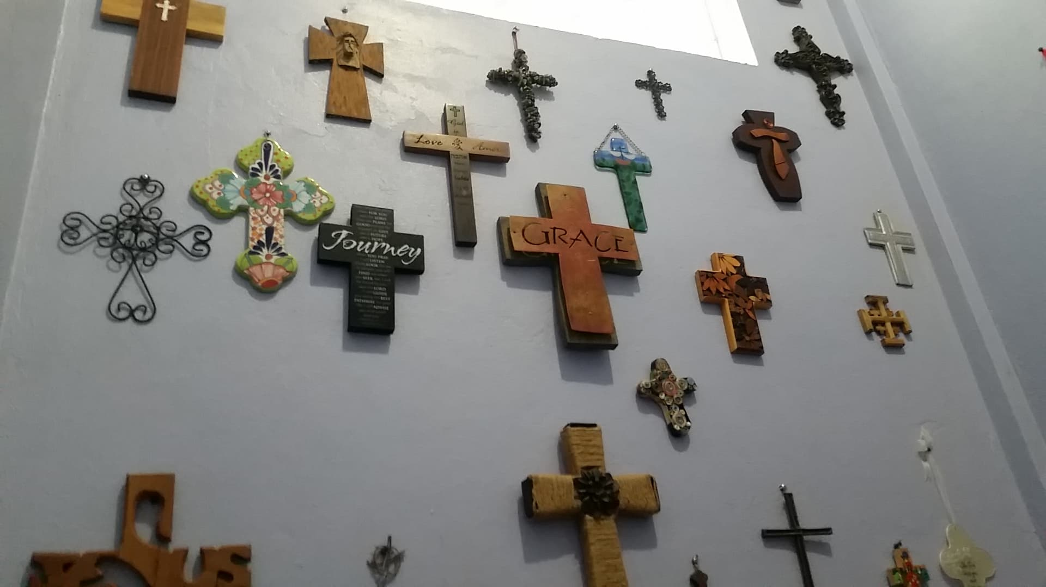
Ministry Update from Kathy McDonald April 2019
HELP me HELP others! STORY #1
Update on Carmela and Tobi:
Carmela is still having problems with her right eye. She is on a new medication to stop the inflammation. She continues doing her little jobs of selling fruits, veggies and tamales. I heard the other day that she was also selling donuts. We are proud of her. Tobi has move in to his father house as of last week. We appreciate all your prayers for them.
Some really sad news to share. Carmela’s foster mother (Toby Pittenger, yes Carmela’s youngest son is named after her) who also was a very good friend of mine, I had the blessing of staying with Toby and visiting her family and church in the last couple of years. Toby has been coming to Belize for 25 years with her church. On Tuesday, Toby and I got up, had coffee together. My friend Shenny and I headed to Belize City to take Toby to the airport. Her flight was delayed and so we share in a nice lunch. We gave hugs and said our good byes and then we heard early Wednesday that Toby had a heart attack and never made it to her earthly home in Ohio but she did make it to her heavenly home. It has been really hard for all of us to understand. But one thing I know is we must Keep Jesus at the Center of your lives. Life is very short, so hug more, love more and seek more of Jesus.
Thank you to all who are helping me to help them.
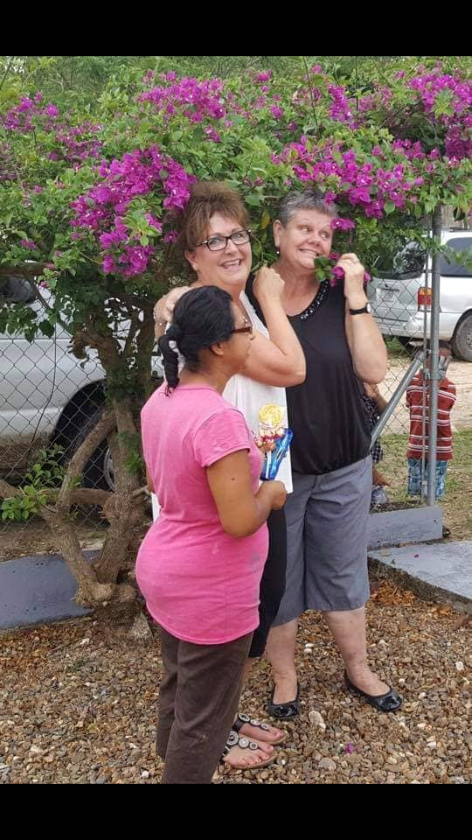
Carmela, Toby and myself
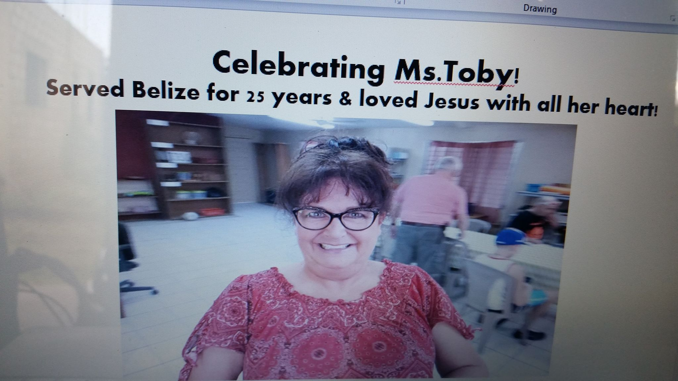

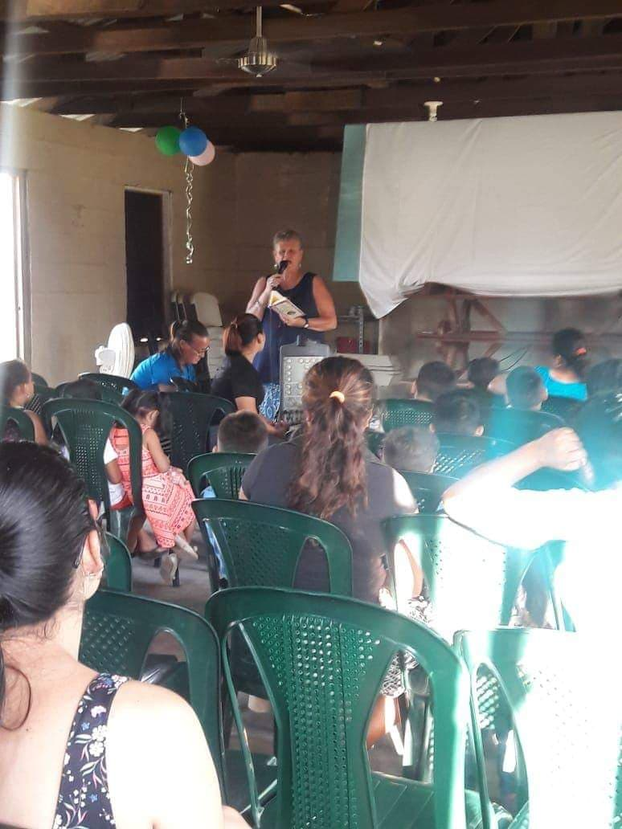

HELP me HELP others! STORY #2
Update: There was a cycling ministry that came to Belize. And their vision was to raise funds for the Freedom House Ministry. They were able to raise $10,000 American Dollars. The first $5000, I took all the guys out for lunch and then we went shopping. What an incredible day it was shopping for Jesus. As I continued to find out the needs of the ministry we shopped and shopped and then did some more shopping.

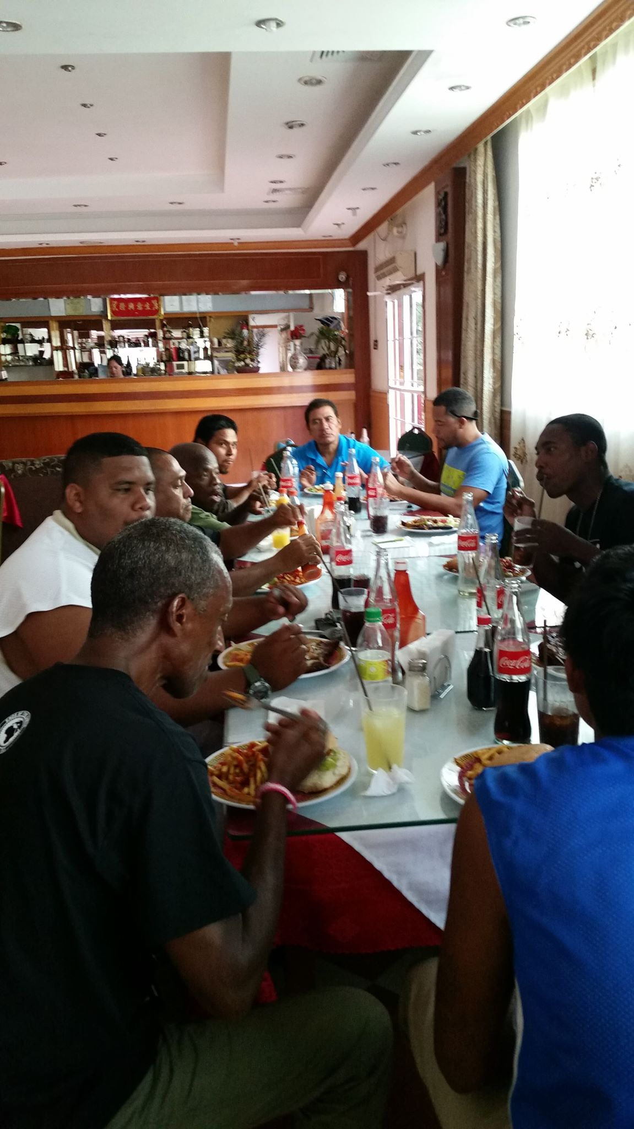
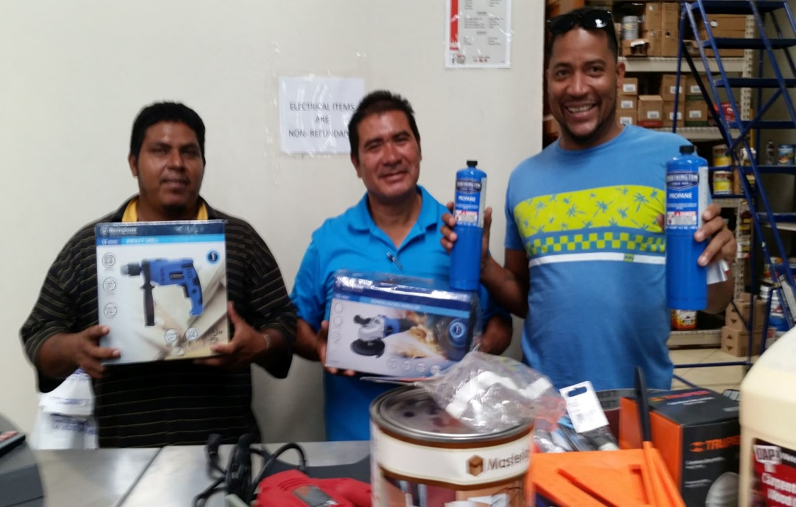

4 of the men got baptized from the Freedom House!
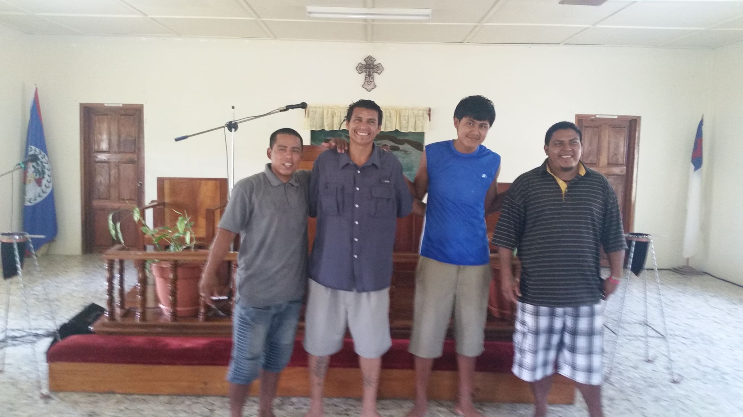
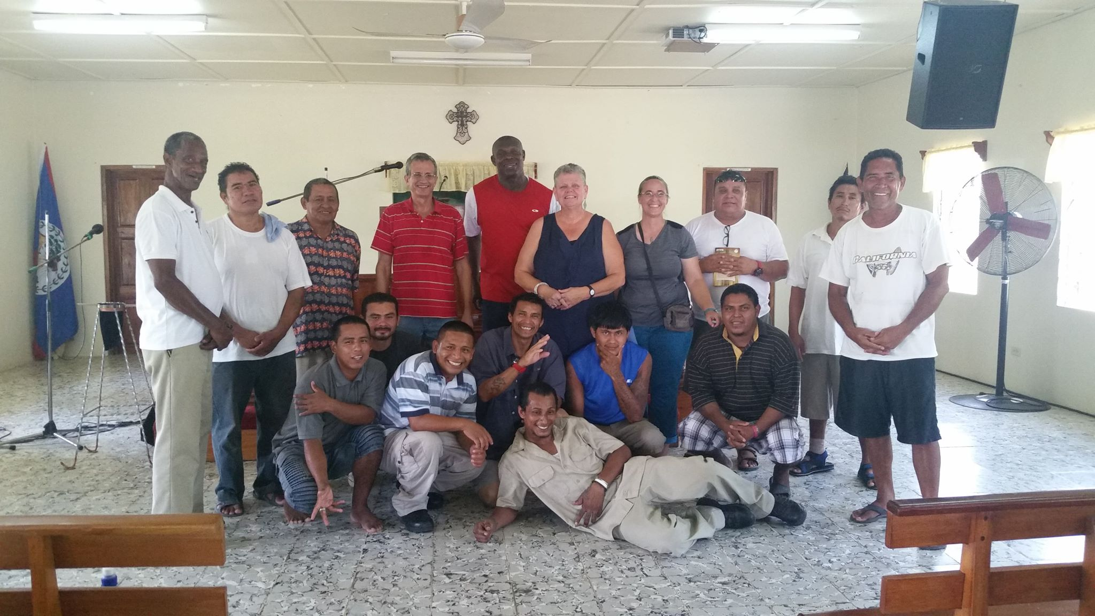
Mission Statement for Freedom House
“To seek the transformation of prisoners and their reconciliation to God, family, and community through the power and truth of Jesus Christ. “

Praising the Lord, yippee, yahooo and happy dancing!
Some amazing news, I got a set of house keys on Tuesday, February 12th 2019
Here is the story!! Some missionary friends were leaving Belize and they heard that I was praying and looking for a ministry house and gave me a call and offered me their home, I sought out counsel with my covering and lots of prayer and I took the offer and moved into a four bedroom house with an office that can be made into a bedroom. Which we did and now I have a five bedroom ministry home.
The house came fully furnished and has a big open concept with living room and kitchen. I had at one time four fridges, two washing machines, and two dryers, two sets of living room furniture, a dish washer and a tool shed that was full of tools. There are two bedrooms down stairs and three bedrooms upstairs, four of the five bedrooms come with air condition units and all came with beds.
We serve a good good Heavenly Father!!

I have opened a little shop to help with the bills and general monthly expenses!
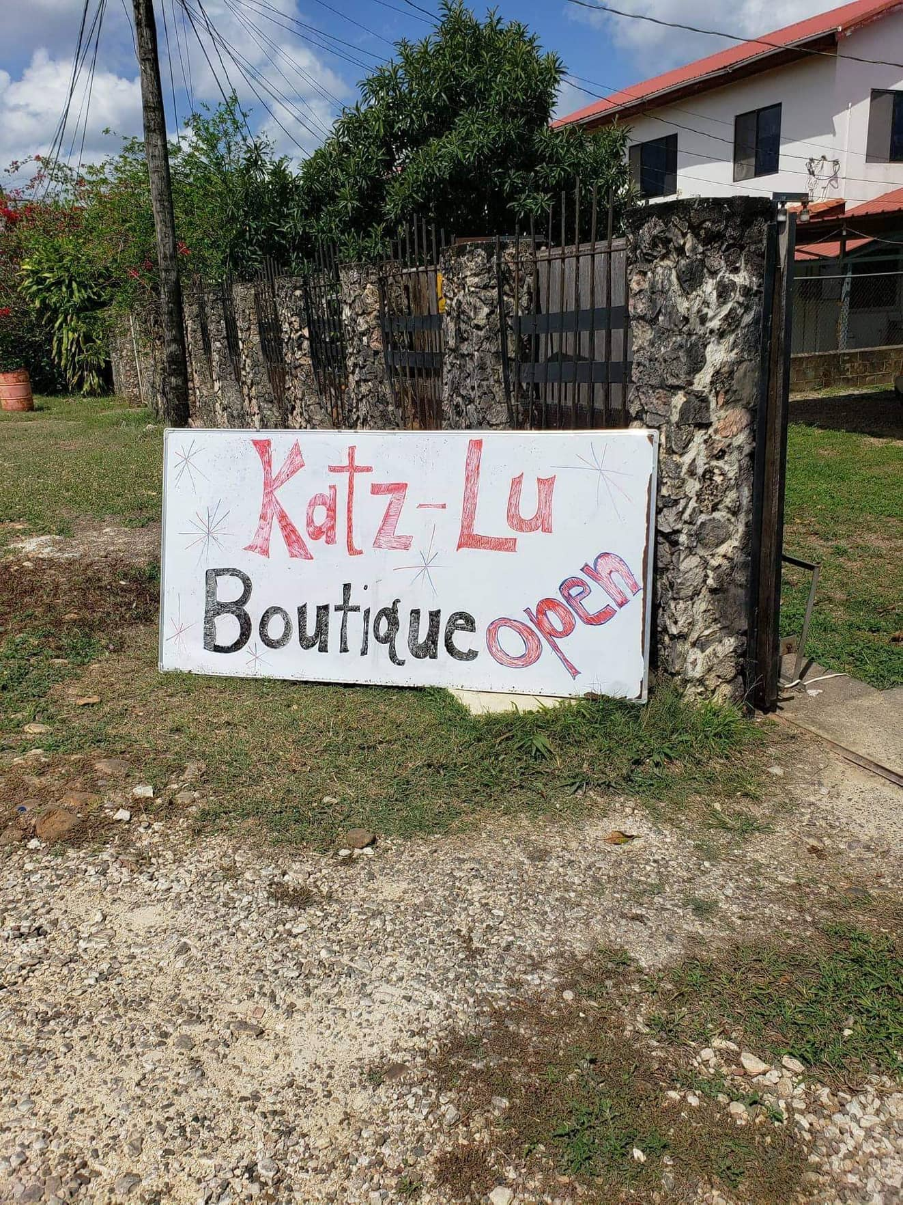

I can do all things through Him who strengthens me!
Philippians 4:13

Guest and Teams who have come to serve in Belize, in the last two month as I hosted them in my new ministry home.
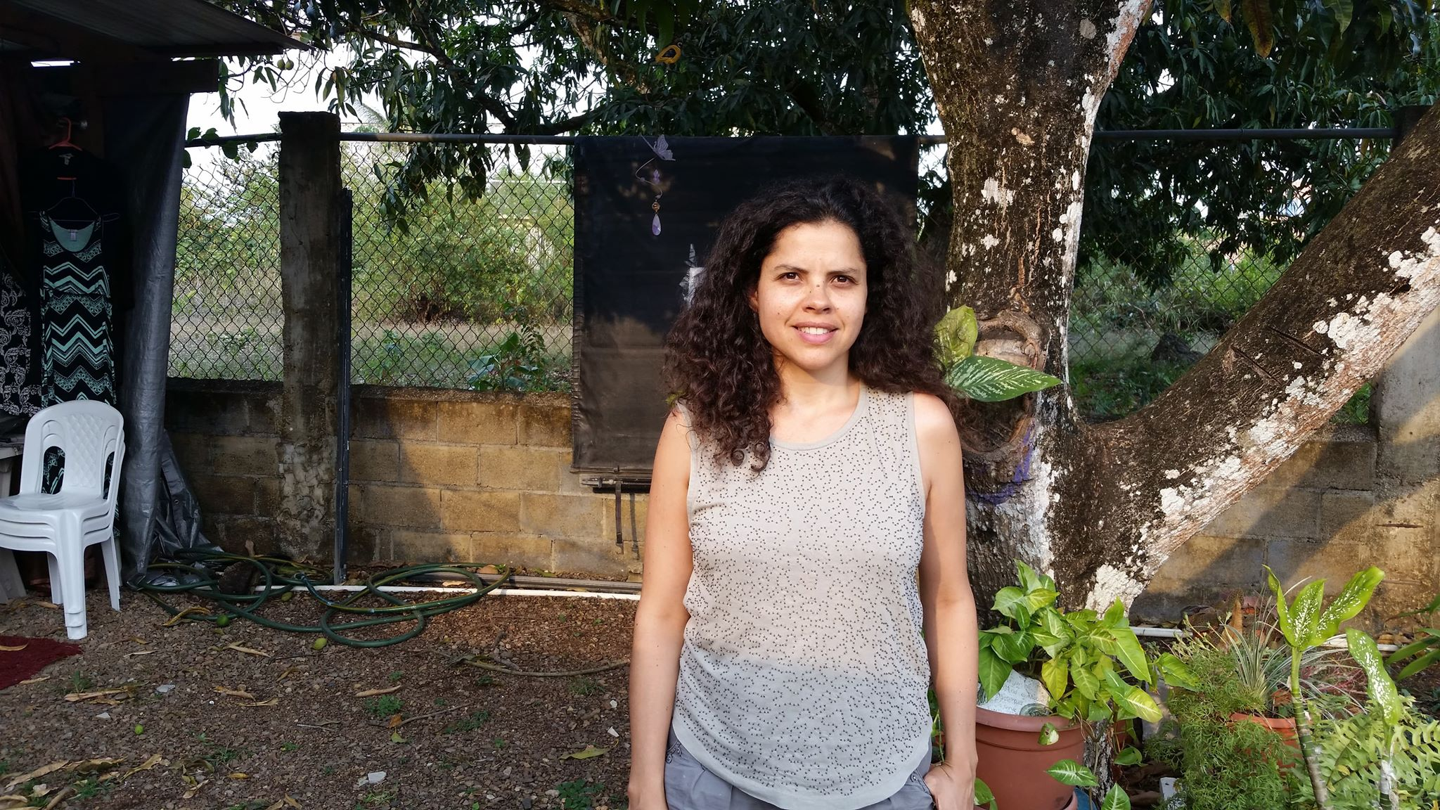Aida from France, was working on her Bachelors of English. She was studying the Belize School System.

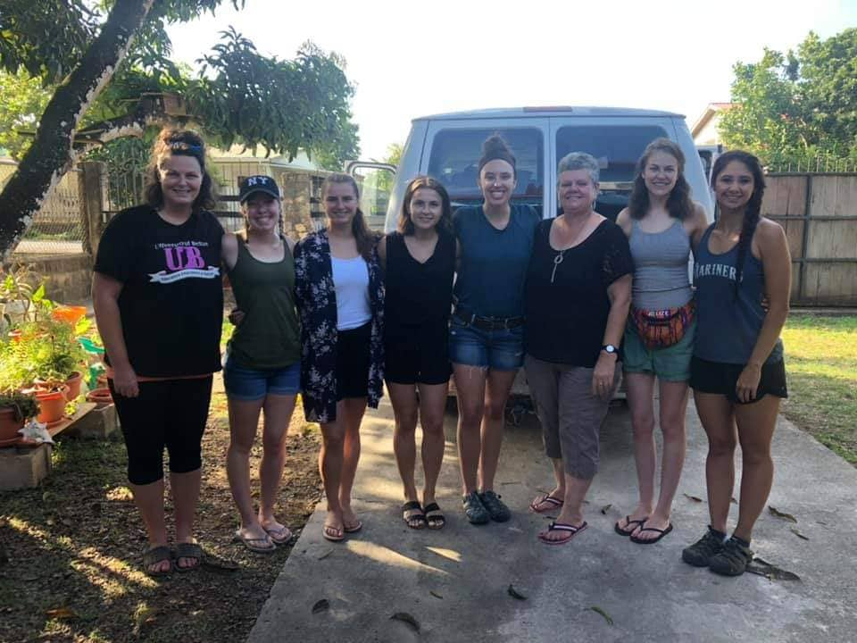
Northwest University nursing students, Kirkland WA, who served in the Belmopan Hospital.

Toby from Ohio, came to spend time with her foster daughter and help set up for her team.
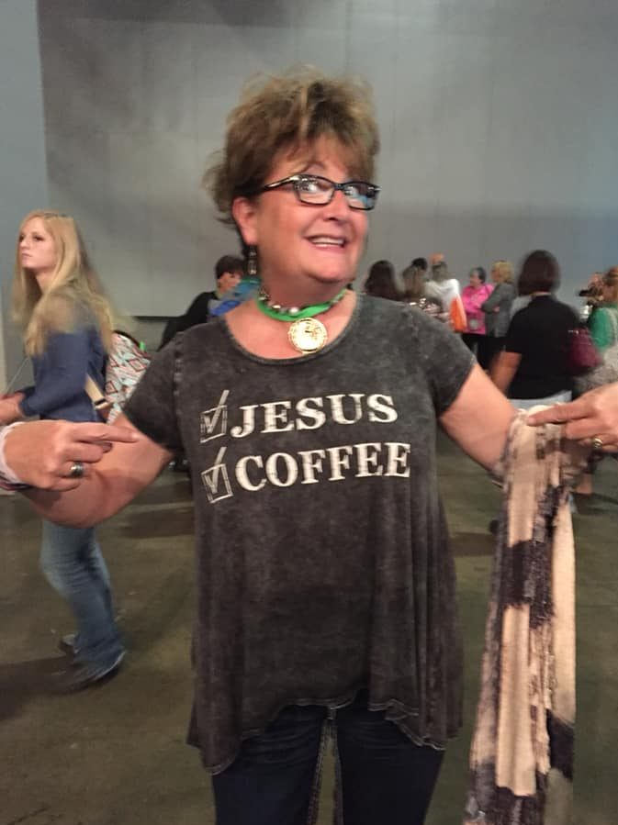

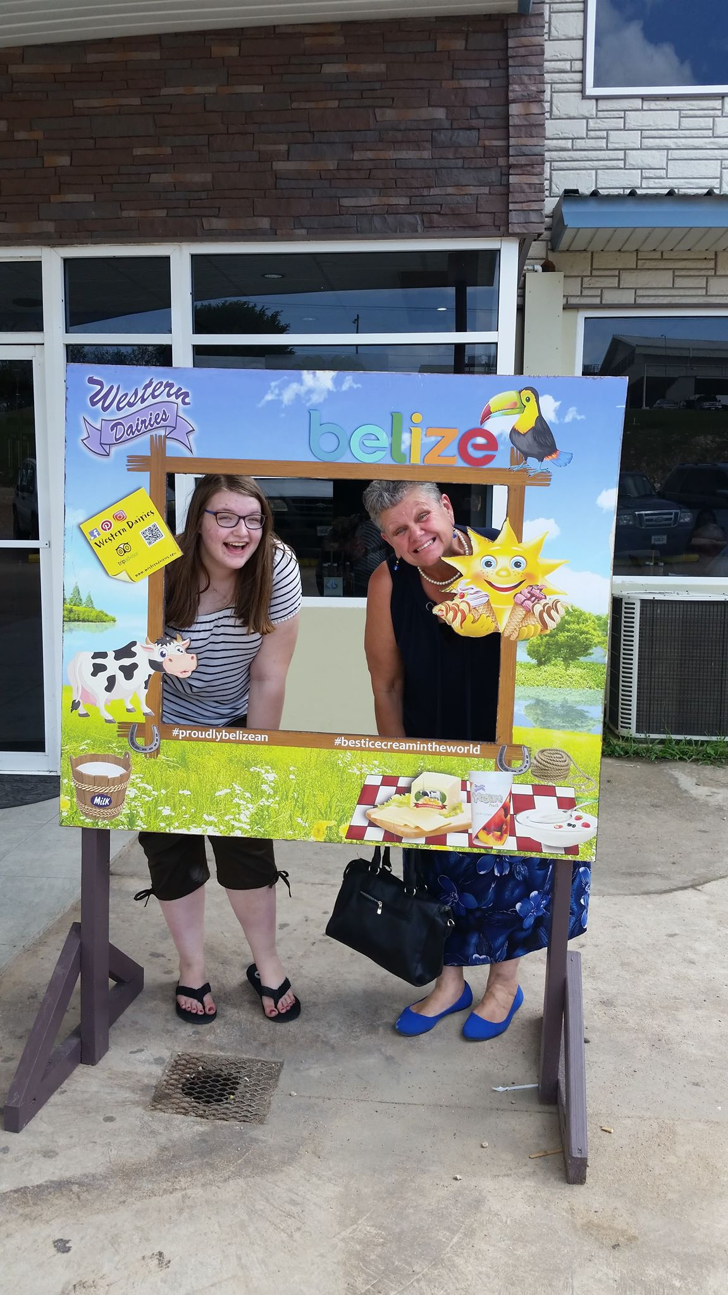 Olivia from Ottawa,Canada, who joined me in a week of ministry.

Plus: One missionary family from southern Belize for an over night stay! And two Guatemalan missionaries for 5 nights stay. Then came to take a vacation.

Single Mom’s Ministry: I’m enjoying helping collect donations for school needs for children. Here are some of their beautiful faces.
Please consider praying for one of these amazing kids!
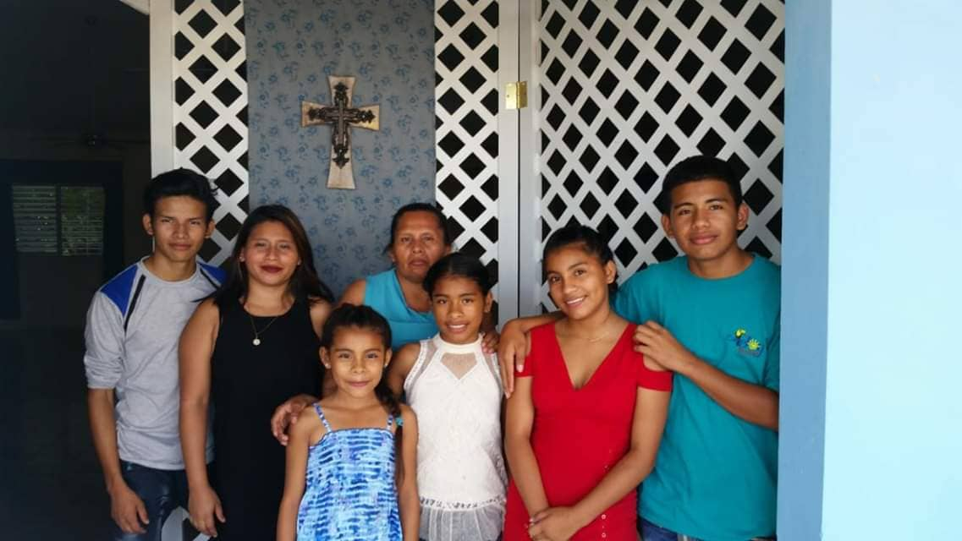

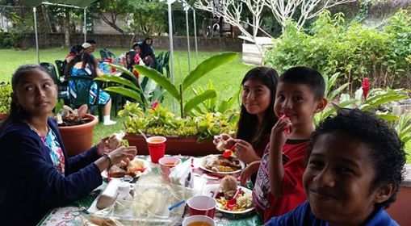

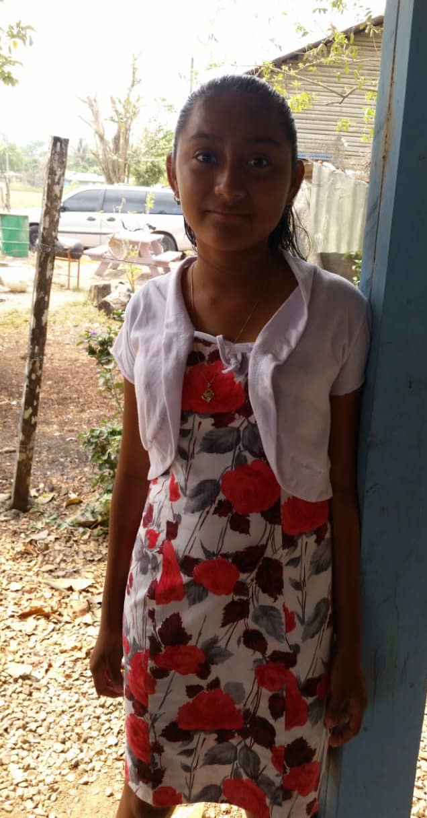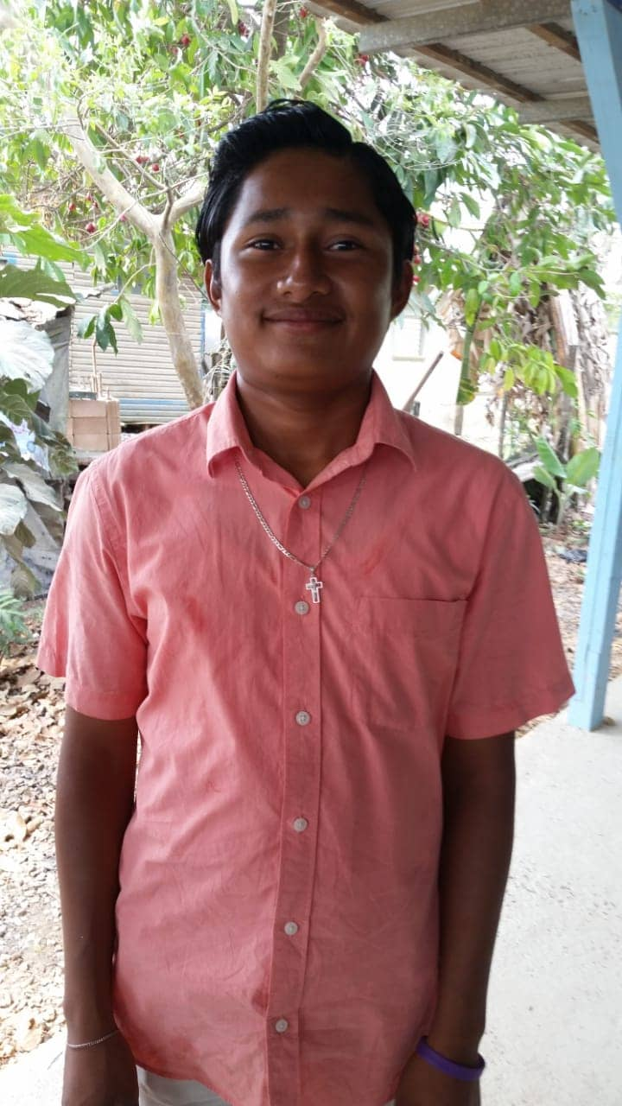

AWANA Global, is a children’s discipleship program that is coming to Belize. In February, I was helping out with airport runs, housing for the leaders, cooking breakfast and just being available to serve in any way. I hope to continue helping in this way into the future as AWANA is established in Belize!

Karla (Hopkins village), Ann (US-ACCI missionary), me and
David (Caribbean Int’l AWANA Director)
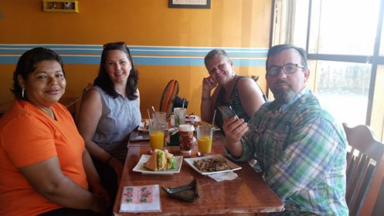

Pictures of the Little Shop and Ministry House
Recently, I decided to add a shop at the ministry house to help fundraise for my ministry needs and to help with the financial commitment I’ve made for paying for the house over time.

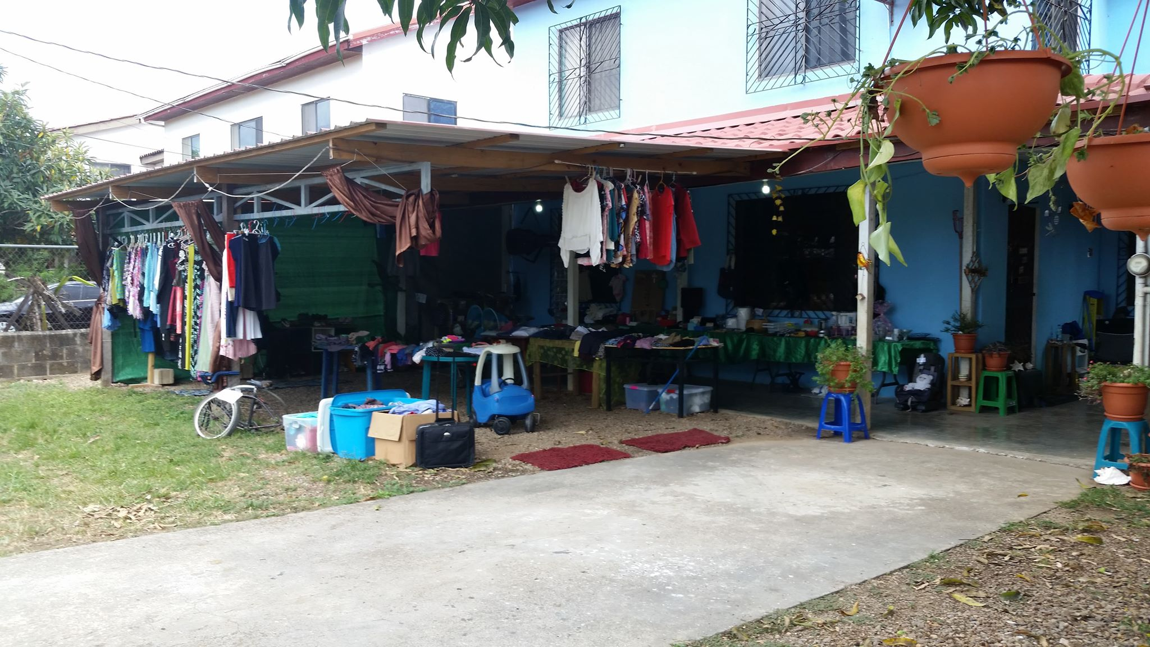

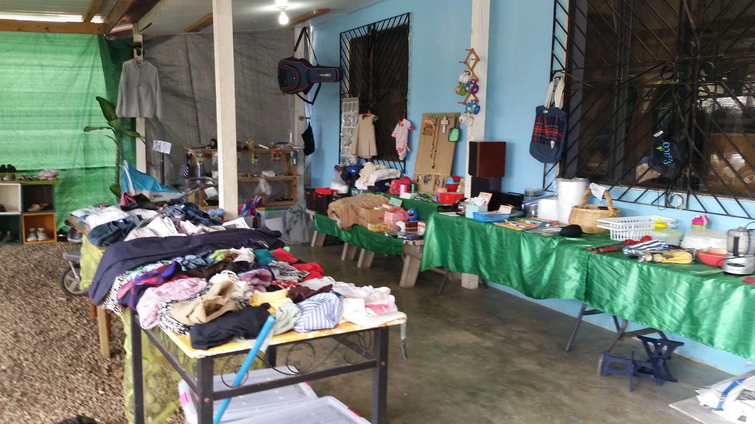
Just outside the front door, a nice cool place to relax
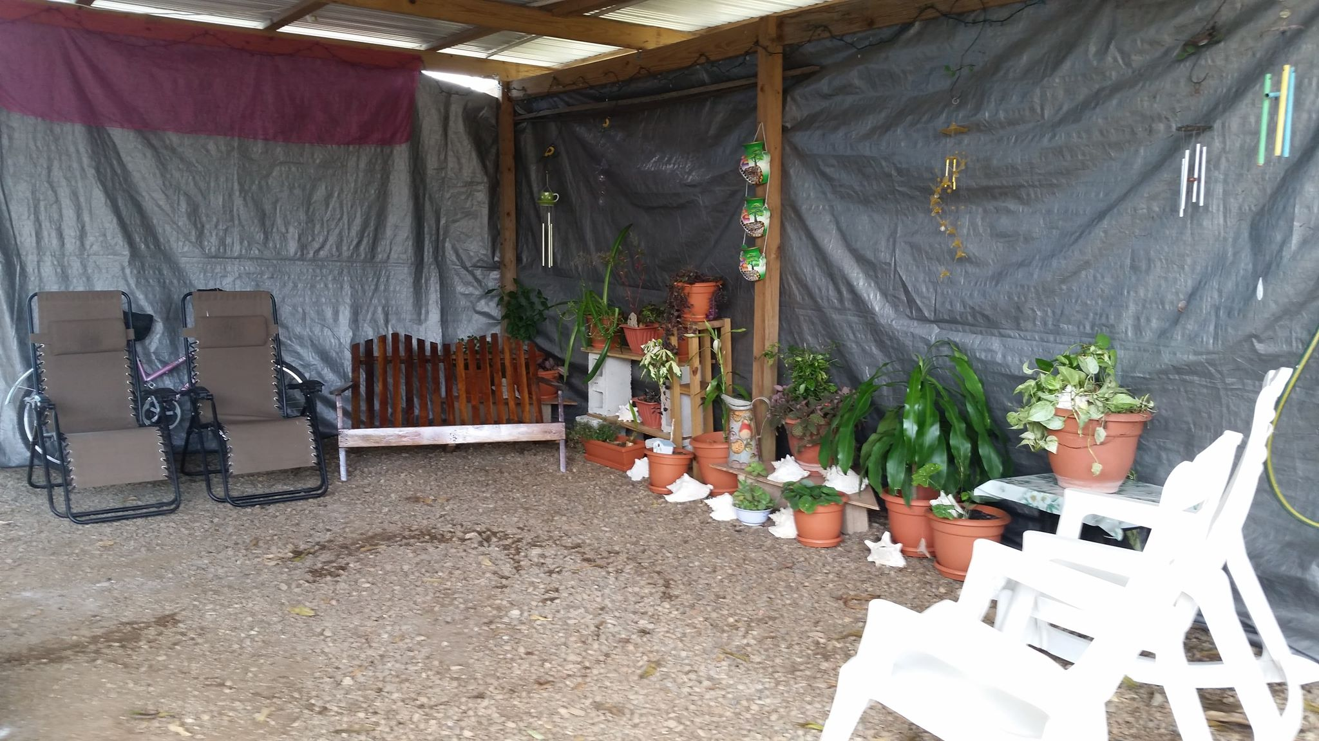
Living Room
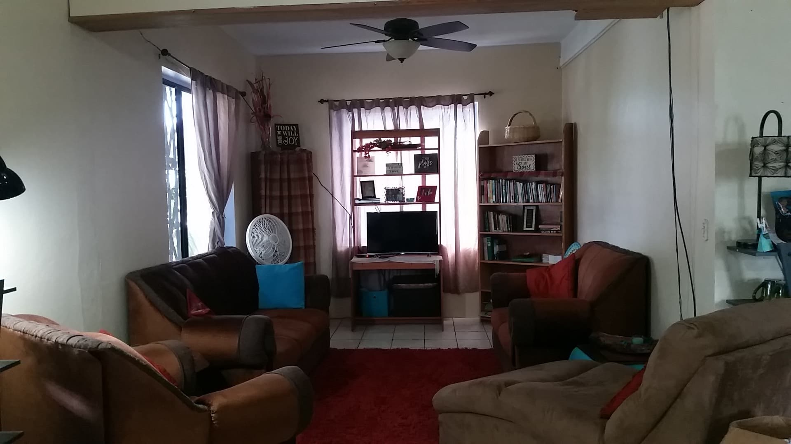
Dining Room
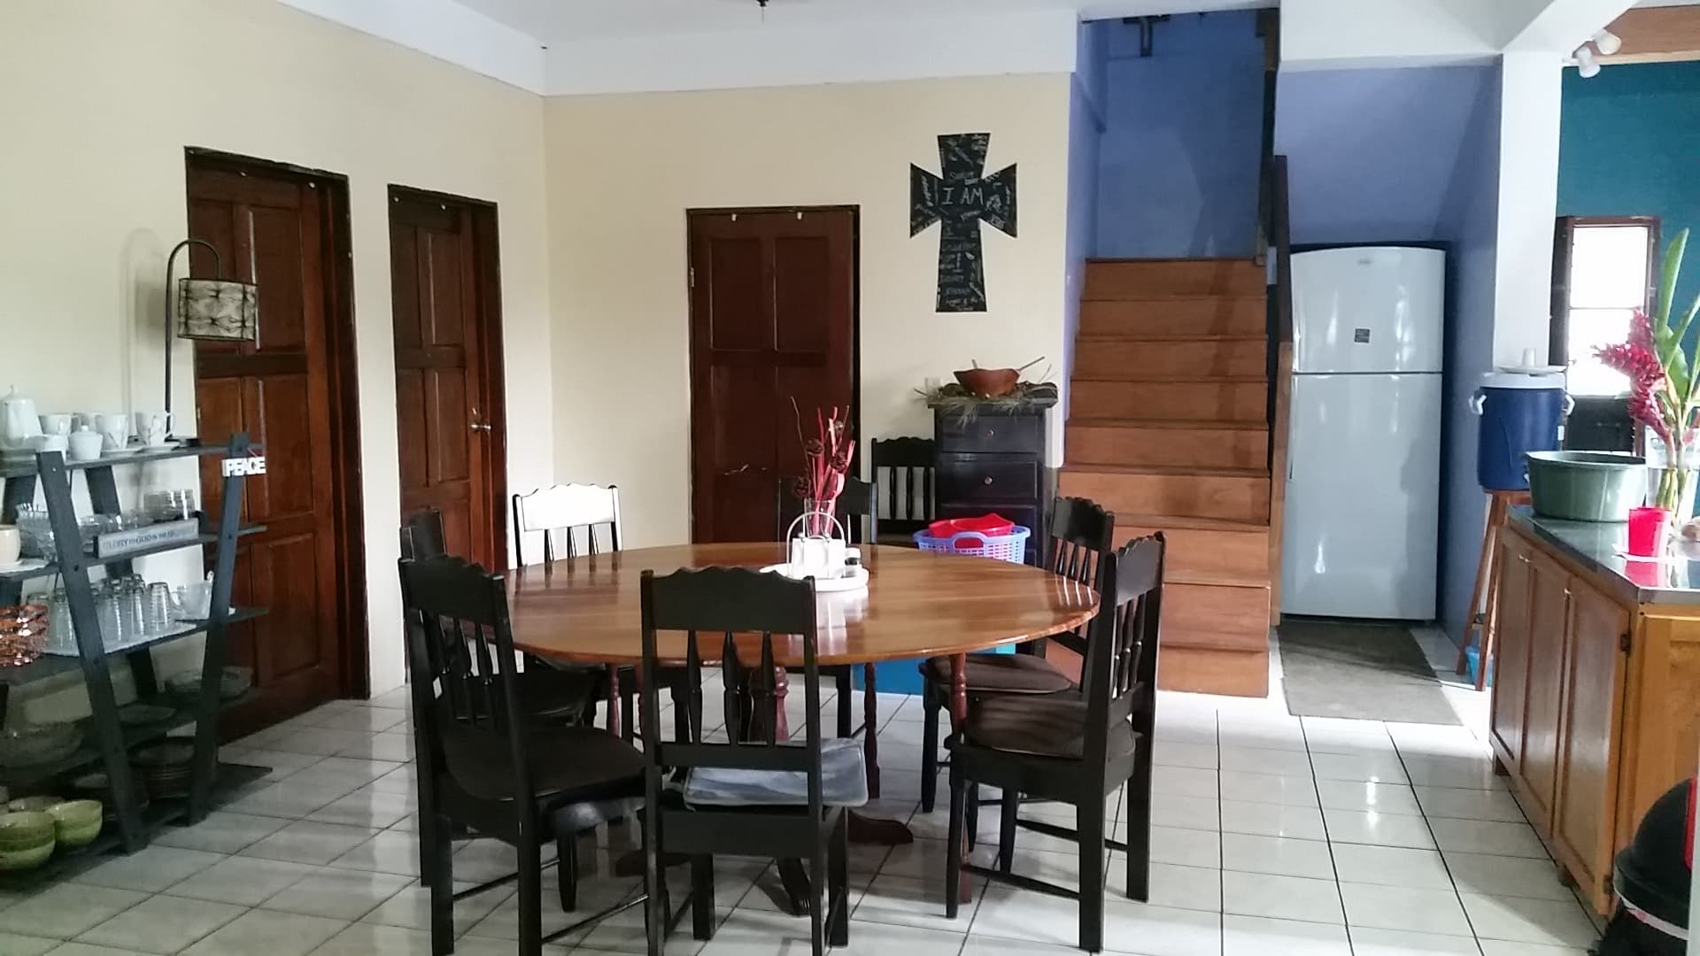

Kitchen
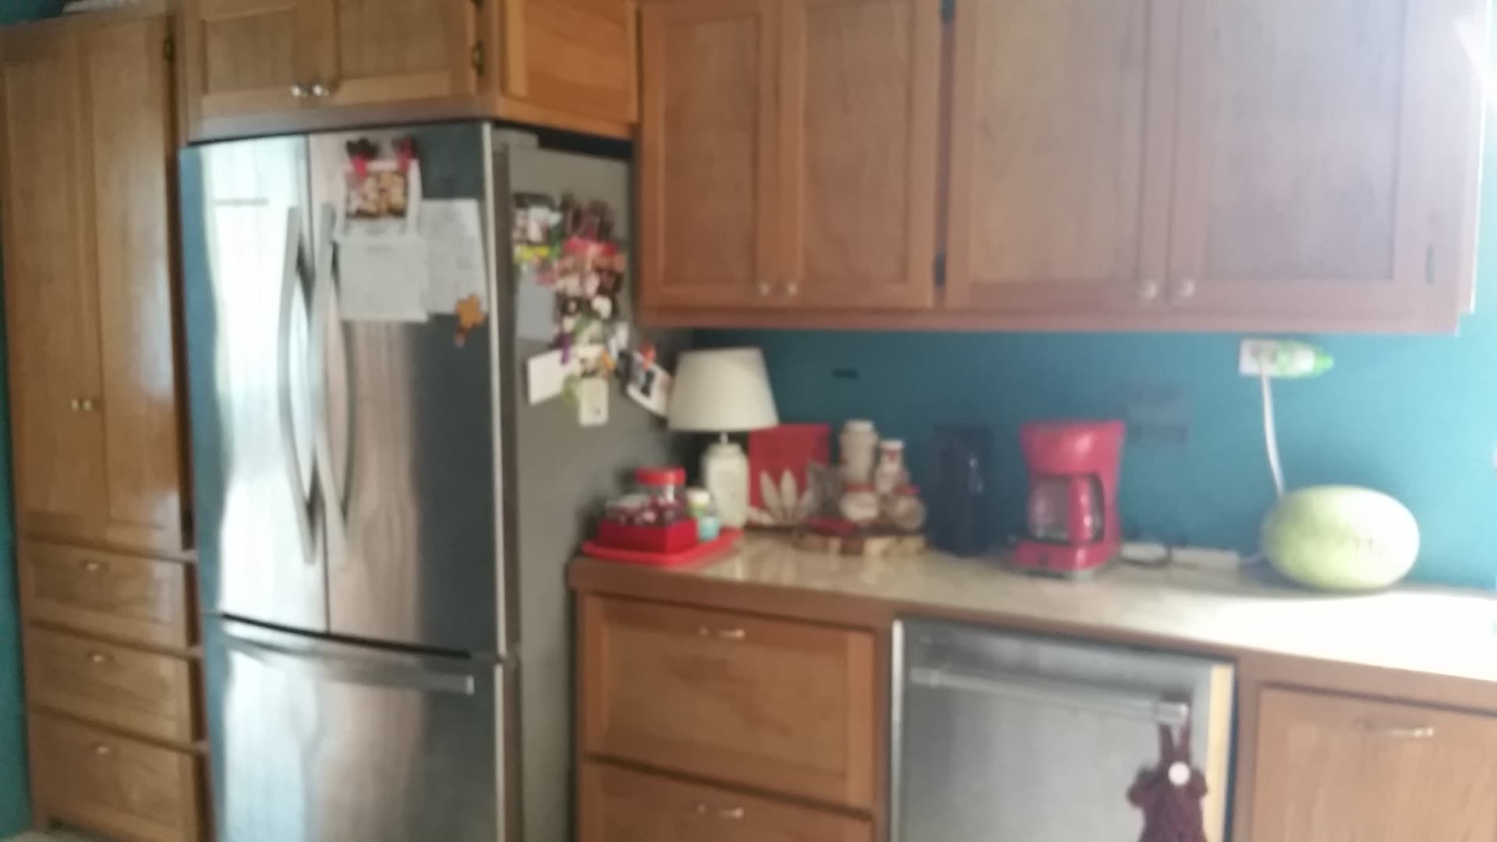
Laundry Room
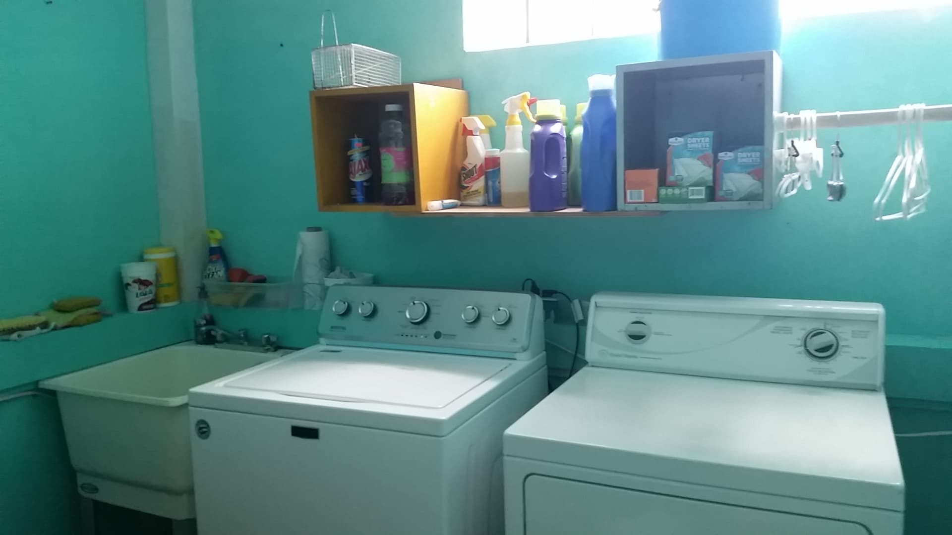
Bedroom Upstairs with a private bathroom
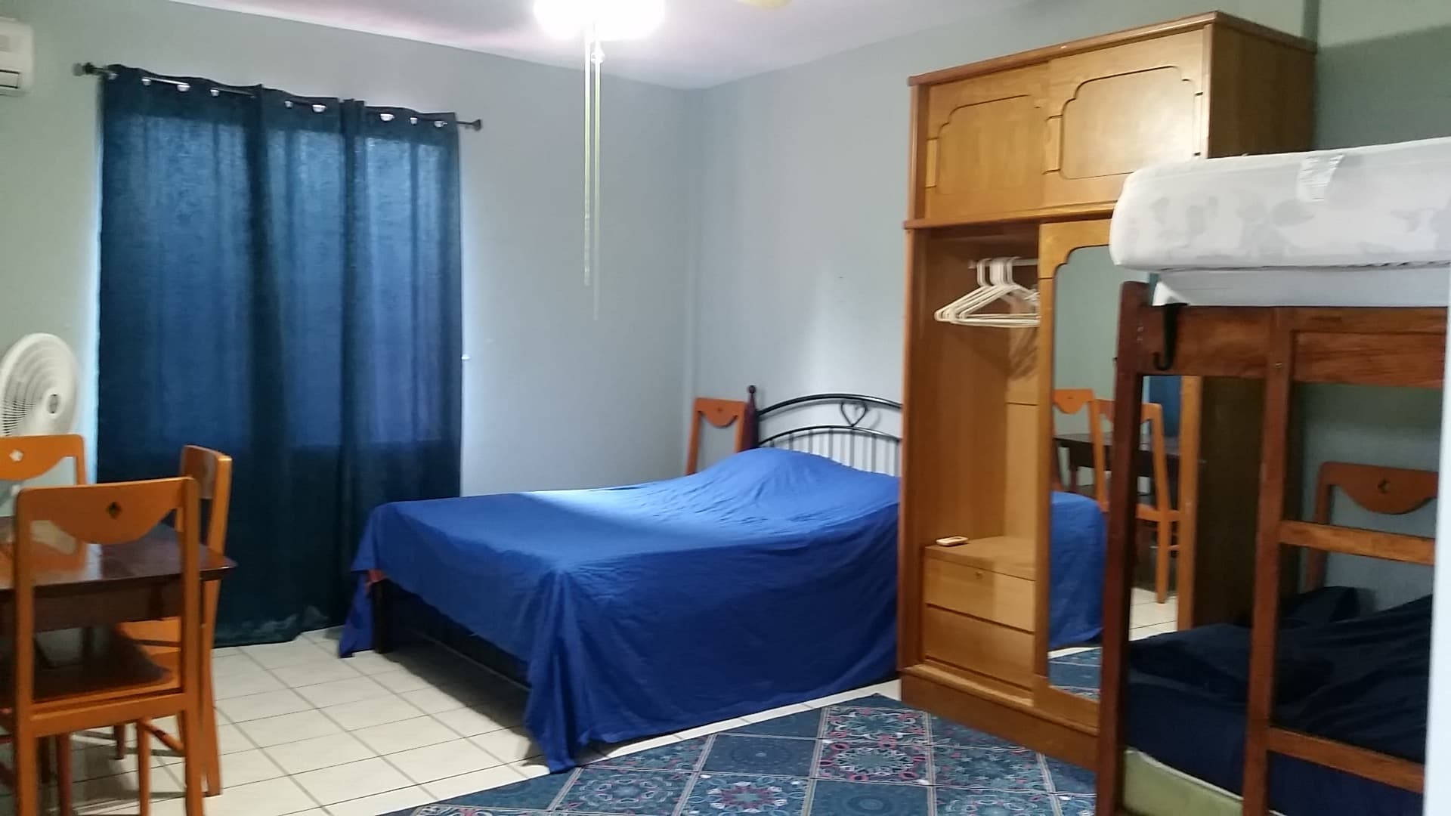

Two Bedrooms Upstairs
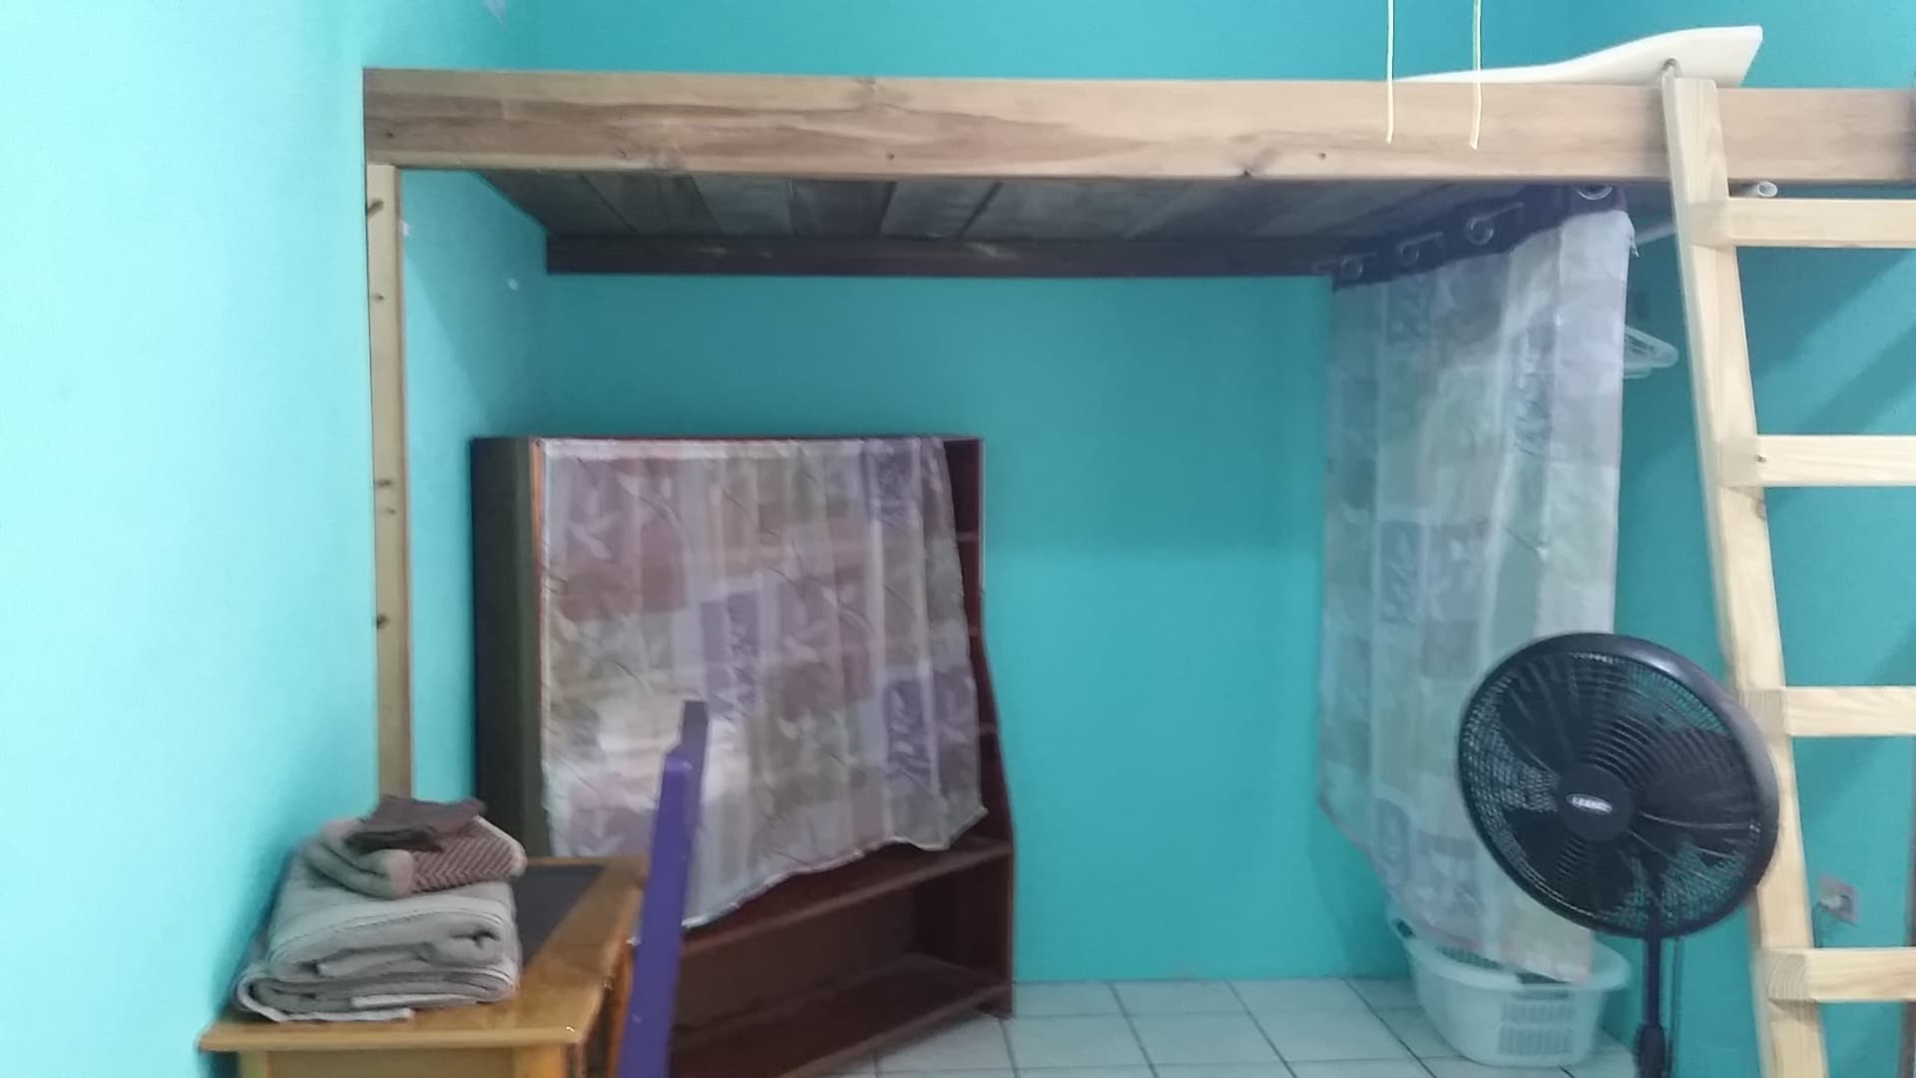
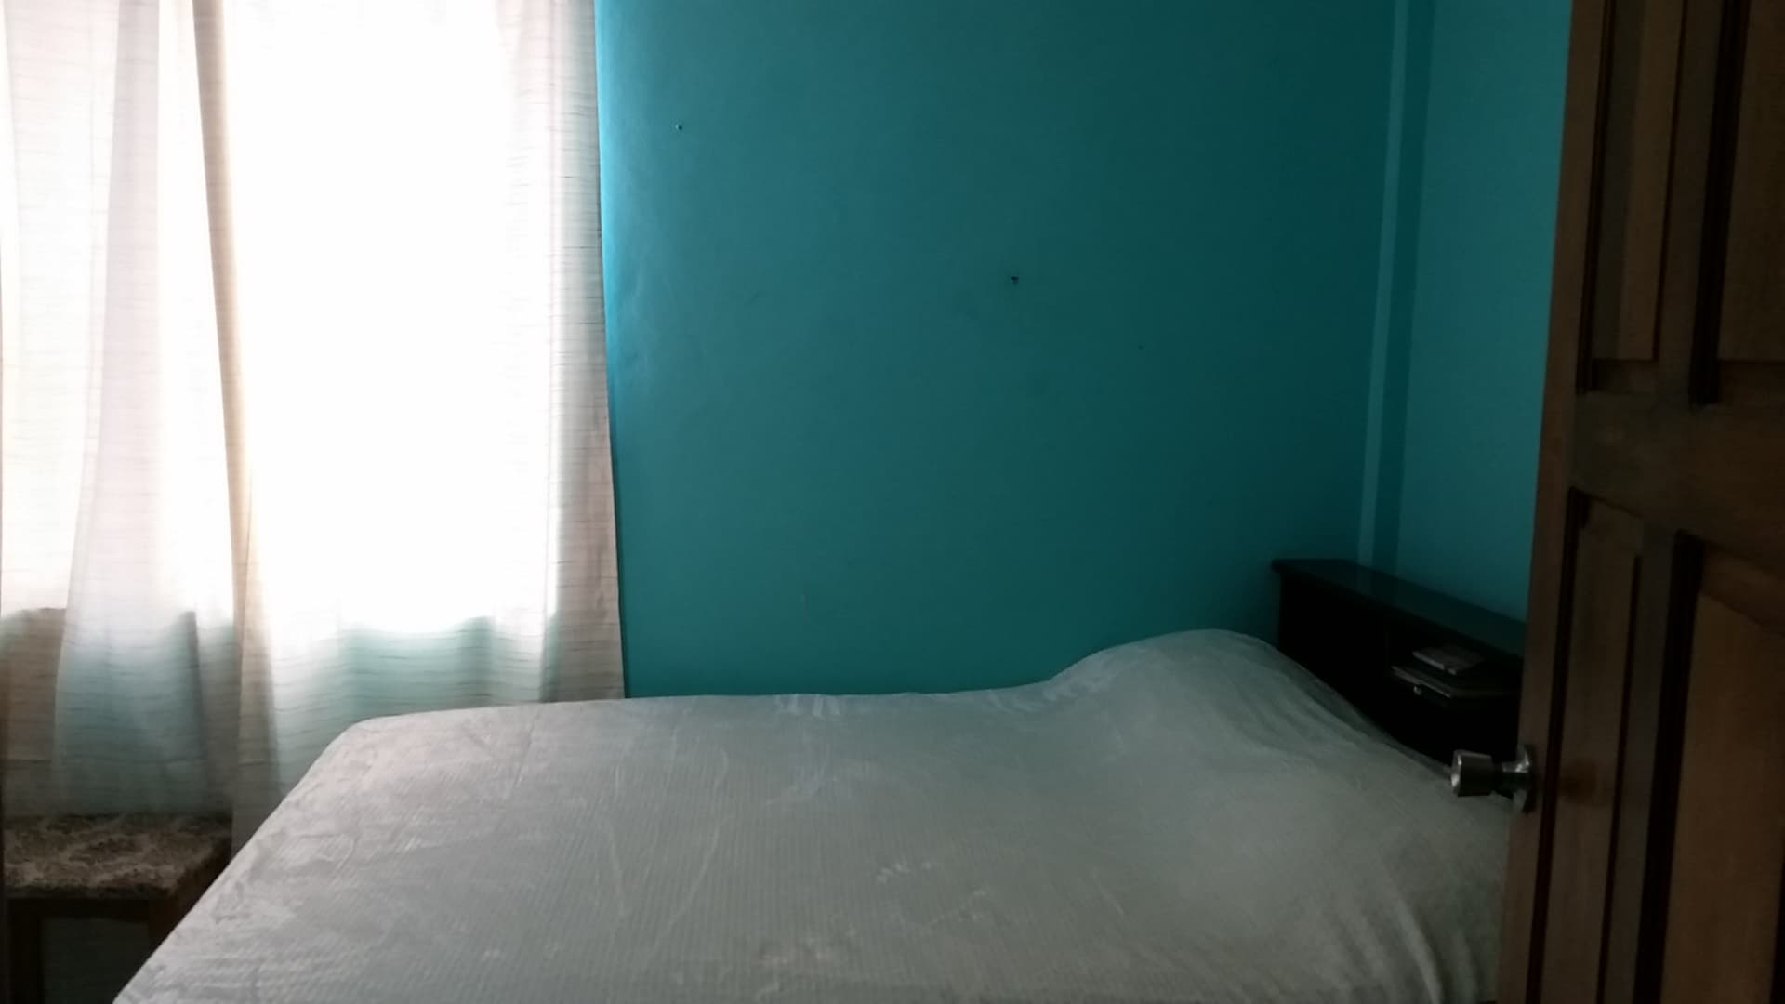
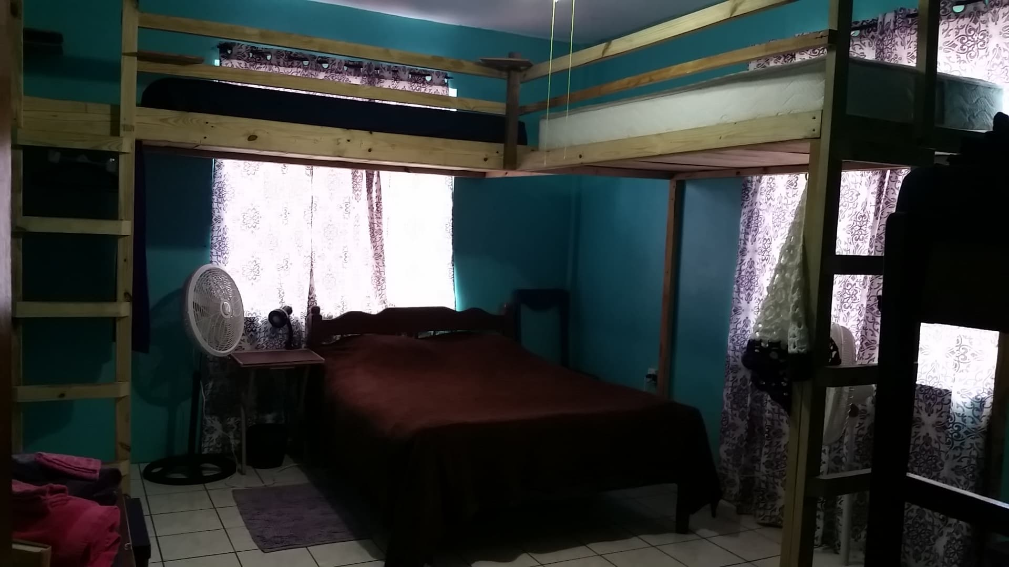

Porch Upstairs
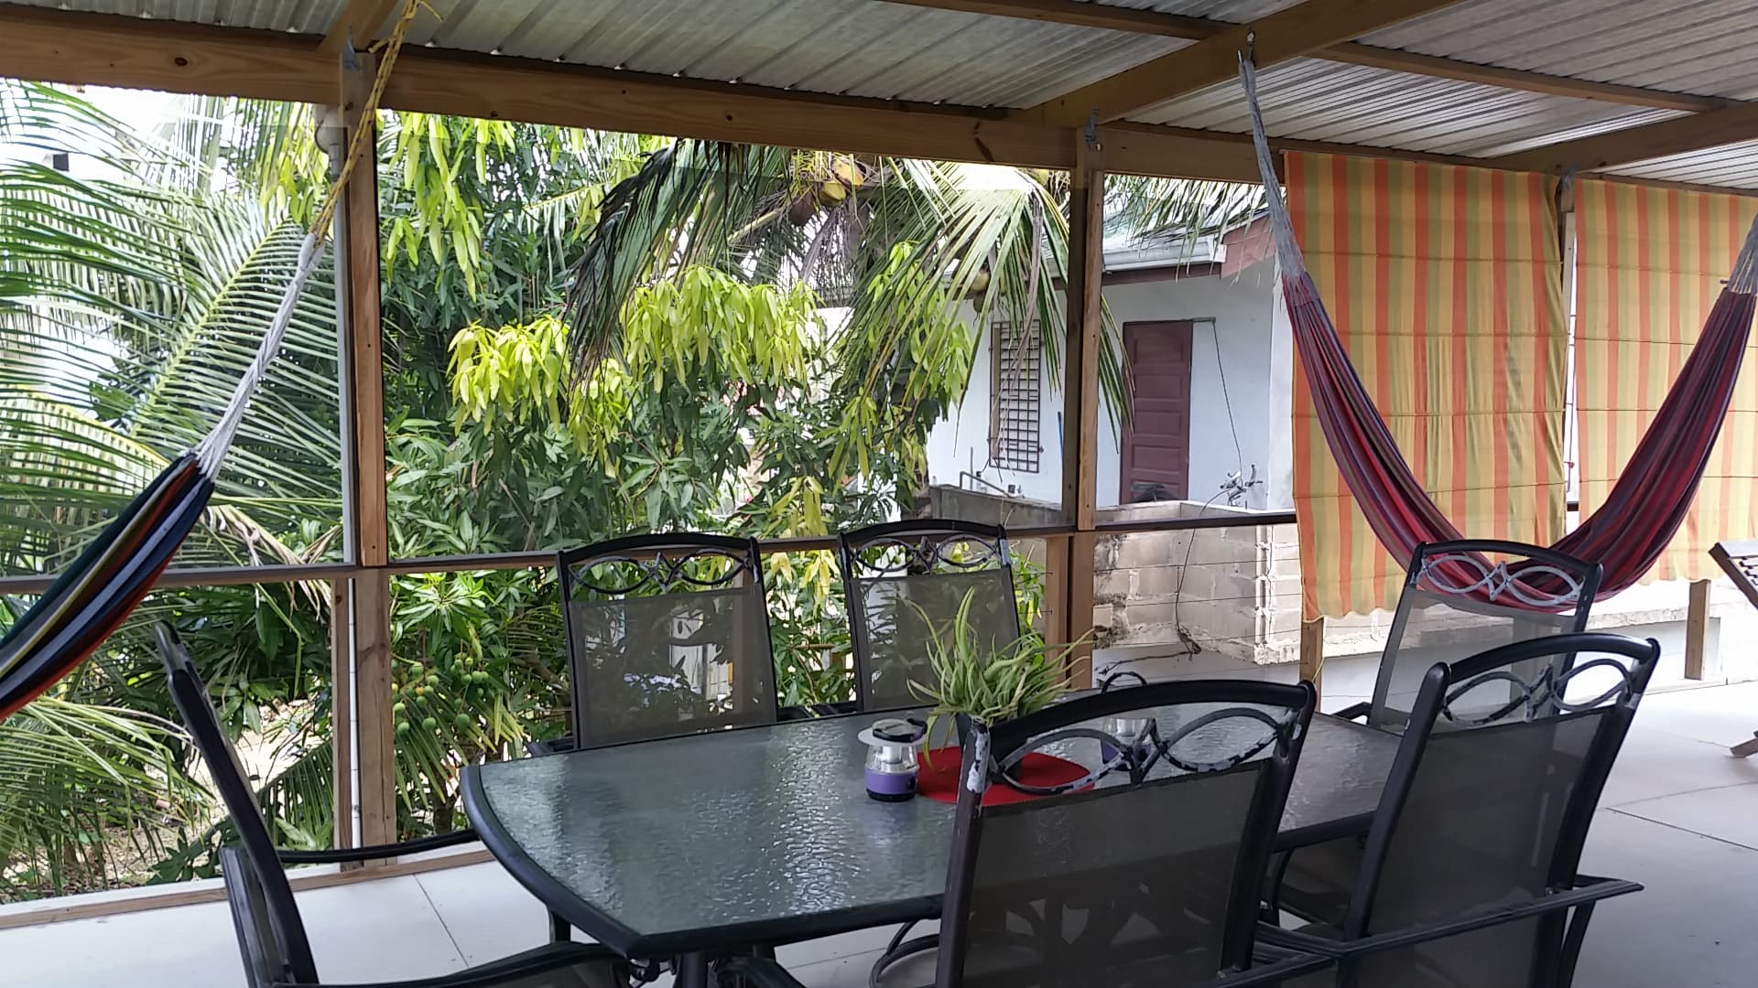
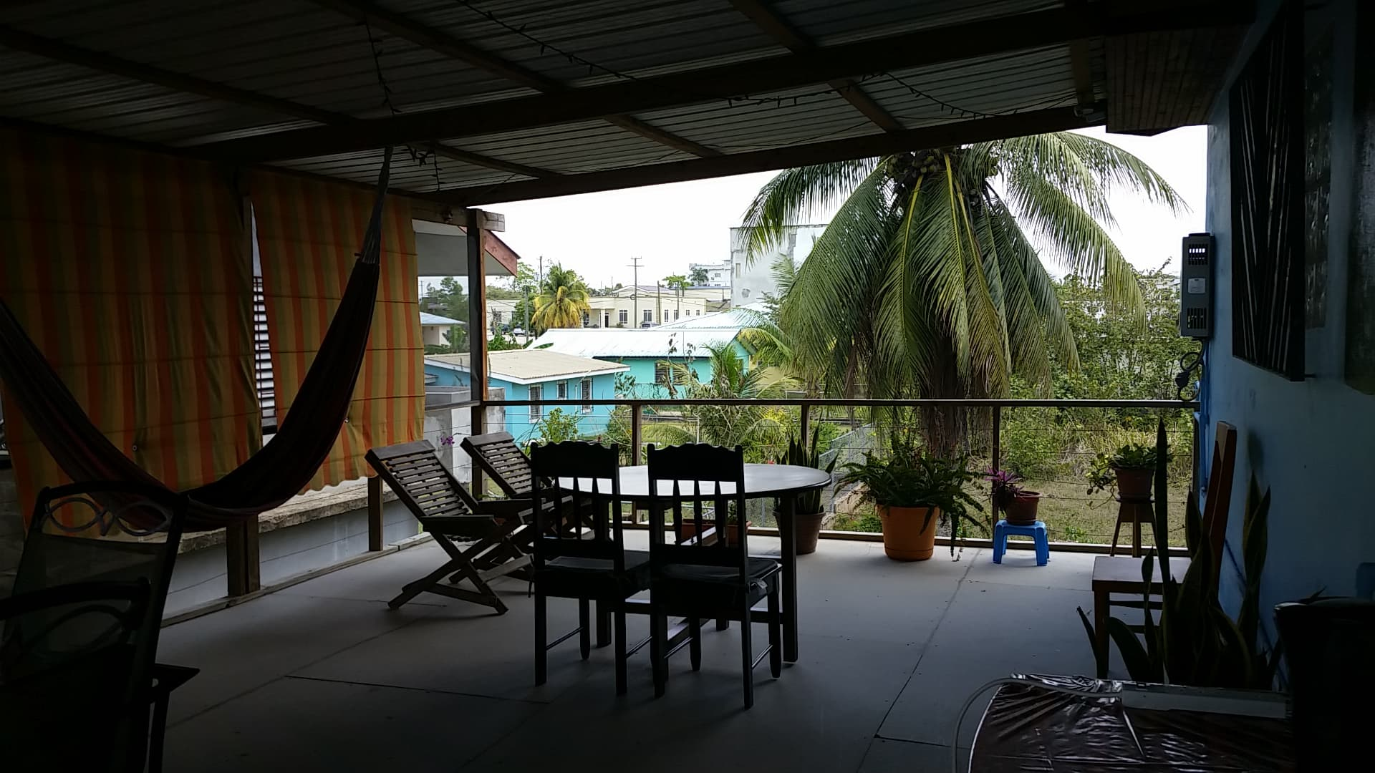

My Ministry Schedule for the next couple of Months
- Friday, May 24th, my friends will help me host a BBQ fundraiser!
- Friday, May 24th in the evening a team of 6 women arrive for a week. I am excited to host them in my new ministry home.
- June 8th, Happy Birthday, I turn 57.
- Thursday, June 27th. I head to Ingersoll, Ontario Canada for the month of Jul
- Sunday, June 30th, Jacky will host a team of 7 nurses for one night
- Saturday, July 13th, Family Summer Reunion
- Friday, July 19th and Saturday, July 20th we will be hosting a gigantic yard sale at my brother Jerrys place in Ingersoll, Ontario, Canada!

Prayer Request
- Grace, Wisdom and Good Health
- Keeping Jesus at the Center of my life
- Increase of Monthly Prayer and Financial Partners

Thank you for being with me in so many ways, as I serve in Belize. You are a tremendous part of my ministry here. Your prayers and financial support is what helps sustain my ability to serve in Belize, long-term. Thank you all!

Blessings in Jesus
Katherine Joy McDonald

If you feel led to give a special donation or become a monthly financial partner, here’s how:

Canadian Partners
- Online Donations -
www.adventive.ca - Click Donate Canada - and choose Kathy McDonald
2. Mail Checks to -
Adventive CCI
89 Auriga Drive
Nepean, Ontario Canada, K2E 7Z2
(Please do not write my name on your memo line of your checks, but include a note designating your donation for, “Katherine McDonald-Belize A3”)

American Partners
- Send through World Outreach Ministries
www.WorldOutreach.org/00211

Web Site
https://makeajoyfulnoisebelize.weebly.com/index.html

